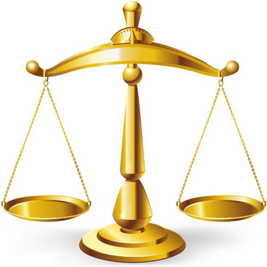
LIST OF KEY PLANNING HEADINGS THAT WILL COUNT IN THE PLANNING BALANCE

- Amenity Impacts
- Archaeology*
- Biodiversity
- Ecology
- Economic Benefits
- Flood Risks
- Good Design
- Heritage*
- Impact on character and appearance*
- Landscape and visual impact*
- Local green space
- Location*
- Site selection*
- Sustainable travel plus disabled access*
- Travel and parking*
*Further details on other display boards

