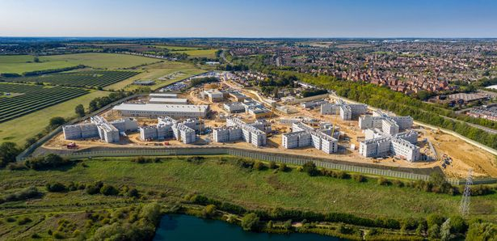
PROPOSED NEW PRISON AT HMP GRENDON AND HMP SPRINGHILL

TOOLKIT WITH GUIDANCE TO MAKING YOUR OBJECTIONS

Also please note that the following resident Exhibitions will take place to offer further information and guidance

- Wednesday 4th August in Grendon Underwood Village Hall
- Friday 6th August in Edgcott Village Hall
- Tuesday 10th August in Steeple Claydon Village Hall
Each Exhibition will run from 3.00pm to 7.00pm

Please bear in mind objections need to be submitted by 3rd September

Produced by Grendon Underwood and Edgcott PC Anti-Prison Working Group
CONTENTS

- How to access the Planning Portal and Documents
- The Planning Balance and planning topics that are taken into account
- Support available
- Different ways to make and submit objections

- HOW TO ACCESS THE PLANNING PORTAL AND DOCUMENTS (Ref: Number: 21/02851/AOP)

- Type the following into your browser and press enter (or see live link on Grendon Underwood or Edgcott Parish Council websites or Facebook pages).

https://publicaccess.aylesburyvaledc.gov.uk/online-applications/applicationDetails.do?activeTab=documents&keyVal=QVYXVBCL0RH00

- Click on the documents tab to bring up all the documents associated with the application.
- To access each document click on the document icon in the right hand column labelled view, this will open the document.
- For convenience and to save having to access the Planning Portal each time you wish to refer to a document you can either:
  - Print a copy of shorter documents by pressing the printer icon in the top right of your screen.
  - Save each document to your computer by pressing the download arrow next to the printer icon or right clicking on the document, choosing “save as” and save to a folder of your choice.
- The most key documents to look at first are:
  - The Comprehensive Landscape Masterplan
  - The Planning Statement
  - The Design and Access Statement

- THE PLANNING BALANCE AND PLANNING TOPICS THAT ARE TAKEN INTO ACCOUNT

- The Planning Balance is how the Planning Officers weigh up the pros and cons of the application. The MoJ will argue that the main advantage of the new prison is an economic one in terms of creating new jobs as well as meeting the Government’s target of increasing the prison estate.
- On the following page is a list of the planning topics that will be assessed by the Planning Team. These are the topics that our objections should be based upon otherwise they will not be regarded as relevant in the planning balance.

- Amenity impacts | 9. Impact on character & appearance
- Archaeology | 10. Landscape & visual impact
- Biodiversity | 11. Local green space
- Ecology | 12. Location
- Economic benefits | 13. Site selection
- Flood risks | 14. Sustainable travel plus disabled drivers
- Good design | 15. Travel & parking
- Heritage

- This may look daunting but have no fear! An ‘Information Sheet’ has been created for each of these 15 planning topics to help objections to be written. Each Information Sheet contains facts and suggested objections relevant to each planning topic.
- Regard the list above as a ‘menu’ and select some of the aspects which you personally are most concerned about (a general idea would be to select a minimum of say 4-6 but that is up to you). Look at the relevant Information Sheets and select parts of the text in each one that you feel best represents how you feel about that particular aspect of the new prison. Try to convert the text in the information sheets into your own words if possible so that each person’s objections are unique.
- You can access the Information Sheets in two ways:
- Go to either of the two Parish Council websites
https://www.gupc.org.uk/ or http://www.edgcottparishcouncil.co.uk
- Request a hard copy and someone from the team will hand deliver the ones that you want copies of. Contact details are shown below in Section 3.
- Of course residents are free to carry out their own research and compile their own objections. However, do make sure that they align with the Planning Topics in the above table or your efforts will be wasted.

- SUPPORT AVAILABLE
If you feel a bit stuck with how to word your objections and would like some assistance please feel free to contact either of the Parish Council Clerks and they will put you in touch with someone who can assist you.
GUPC clerk.gupc@outlook.com Tel: 07873 683043
EDGCOTT PC edgcottparishclerk@gmail.com Tel: 01296 770568
- HOW TO SUBMIT YOUR OBJECTIONS (DEADLINE FRIDAY 3RD SEPTEMBER)
There are a few ways in which residents can make their objections and these are described below.
- On the same screen as you used to access the documents there is a tab at the top of the page, click on the Make a Comment box.

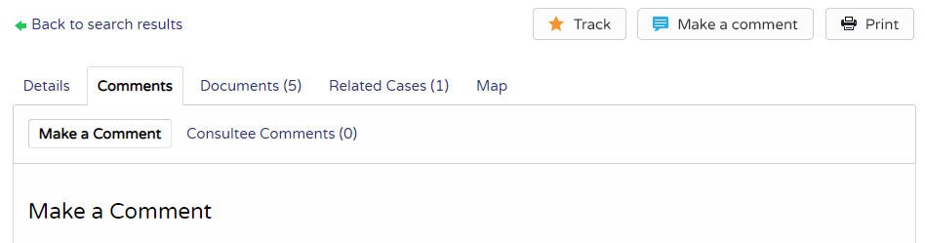

- You then see an online form where you need to submit your personal details and then at the bottom is a box to submit your response.

N.B. You can type your response up in a word processing document and copy and paste it into the comments box. Do check the formatting has copied over correctly though. This approach will not work for tables, maps and photographs; see below if your objections contains such items.
- When you are finished you can either click Submit or Submit and Register. The latter then allows you to track any applications that you wish to follow. You will be sent an email if any updates are posted.
ALTERNATIVE WAYS TO SUBMIT YOUR OBJECTION
By email - devcontrol.av@buckinghamshire.gov.uk
This is the best way to forward objections that include photos, maps, tables and other formats apart from standard text.
You will need to provide the following information:

• Your name and address
• The application reference number Ref: Number: (21/02851/AOP) and the address of the site
• Whether you are supporting, objecting to, or commenting on the proposal
• Details of your comments

By post – Planning Department
Buckinghamshire Council
Aylesbury Vale Area Office
The Gateway
Gatehouse Road. Aylesbury
HP19 8FF

N.B. Please include the reference number for the planning application plus your full name and address. Also state if you are supporting, objecting to or commenting on the proposal.

