PROPOSED MEGA PRISON AT GRENDON UNDERWOOD
INFORMATION SHEET ON ARCHAEOLOGY

Note: The Bucks Council Archaeology team will be a consultee on the archaeological aspects of the planning application and we do know that they were consulted in July 2020 at the pre-planning stage. The main archaeologist at Bucks Council is very familiar with the area. It is also likely that Historic England will be a consultee and they may also have been involved at the pre-planning stage.

- Objection Details
- Potential for evidence of Roman occupation on the current prison estate is high, given the proximity to Akeman Street and archaeological evidence nearby along the route of HS2. The medieval Forest of Bernwood provides this area with a unique heritage, many of the features and place names being a direct legacy of the ancient royal forest. Potential for evidence associated with the Forest particularly relates to banks, routes, boundaries and buildings.

Grendon Hall has been Grade II listed since 1985. As well as the Hall, there was a stable block, stable yard crenelated walls, lodge (gone), and associated structures. The structures were united in the design using fashionable Jacobean style in red brick with stone dressings. Like country houses of that period it also had a large park and pleasure gardens associated with it. The layout comprised a largely typical ensemble of pleasure ground and park for a country house developed in the 1880s with buildings in Jacobean style. The 1880s design incorporated hedgerow trees as specimens in the new park and a straight main drive was framed by an avenue. Some of the early specimens survive enclosing the informal lawns within the modest pleasure ground. Elements lost to development include the 7ha. housing estate in the south park and prison buildings east and south of the Hall. The rural setting enjoys views over the Vale of Aylesbury to the south, south-east and west. The setting has already been significantly damaged by the large prison development east of the Hall. (See: The Buckinghamshire Gardens Trust Research & Recording Project, Grendon Hall Issued March 2021 (revised June 2021).

- The western part of the historic park of Grendon Hall is rich in ridge and furrow. Potential exists for former features related to the designed landscape since the 1880s, such as buildings, paths, beds, terraces, boundaries, and the lost north drive to be uncovered.

- The building of a new site entrance, north of Willow Lodge, and a new road up the whole length of the western part of the Historic Park of Grendon Hall will have an irreversible and significantly harmful impact on the green field space which separates Grendon Road from Grendon Hall. Relocating the football pitch to this field as well just exacerbates the irreversible harm that will be done to this much valued space and landscape. The impact on the amenity benefit is also a significant consideration.

- Due to the construction of the new site road and the football pitch in the area of ridge and furrow adjacent to Willow Lodge there is a potential loss of artefacts hidden beneath the site.

- There would be a cumulative impact on the loss of archaeological value if the new mega prison went ahead due to the current infrastructure projects like HS2 and East West Rail.
- Grendon Underwood parish was enclosed in 1769. In 1995 there was only approximately 26% of the original ridge and furrow land remaining. More has disappeared since then and hence any remaining amounts should be given due respect and protected from destruction.

- There is evidence, from looking at old maps and photos that the current prison estate used to be part of a large area of historic ridge and furrow (see below). It appears that Grendon Hall and the two current prisons, as well as the Springhill housing estate, on the site were built on ridge and furrow land before such areas were protected in any way. Hence the field where the proposed new site entrance will be located, and the football pitch will be relocated to, is an important, remaining part of ridge and furrow land in the western part of the site.

- Loss of green field space. The site makes a positive contribution to the character and appearance of the local area. Special attention should be paid to the desirability of preserving or enhancing the character or appearance of that area rather than carrying out a sprawling urbanisation of the site.

- Archaeological remains are irreplaceable and vulnerable. Careful management is therefore essential to ensure that this important heritage survives in good condition. Landowners, farm managers and Councils are in a crucial position to achieve this aim and should do so.

- Below is a photo of the ridge and furrow between Grendon Road and Grendon Hall taken after light snow in January 2021
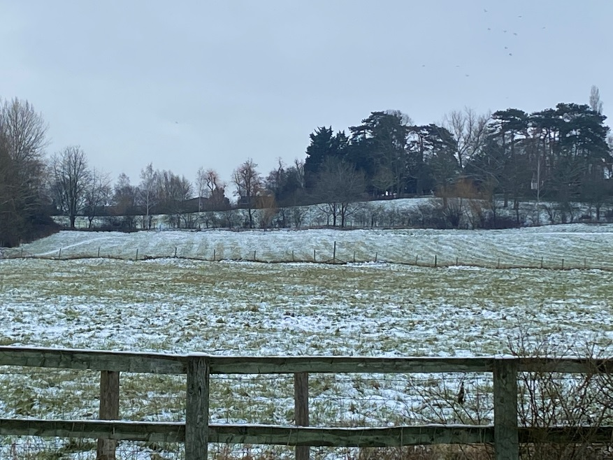
Clear evidence of the ridge and furrow between Grendon Road and Grendon Hall, Jan 2021

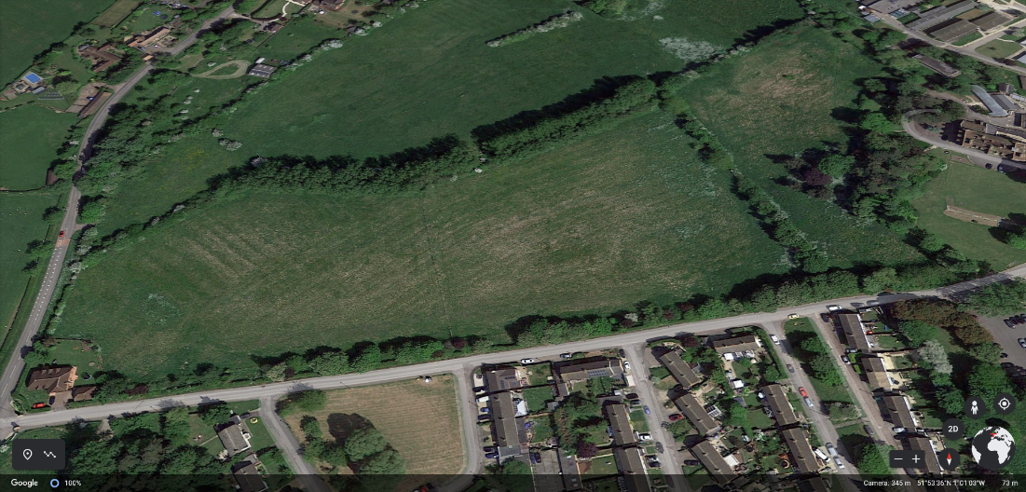
Aerial photo showing ridge and furrow on the field where the new site entrance is due to be located along with the relocated football field
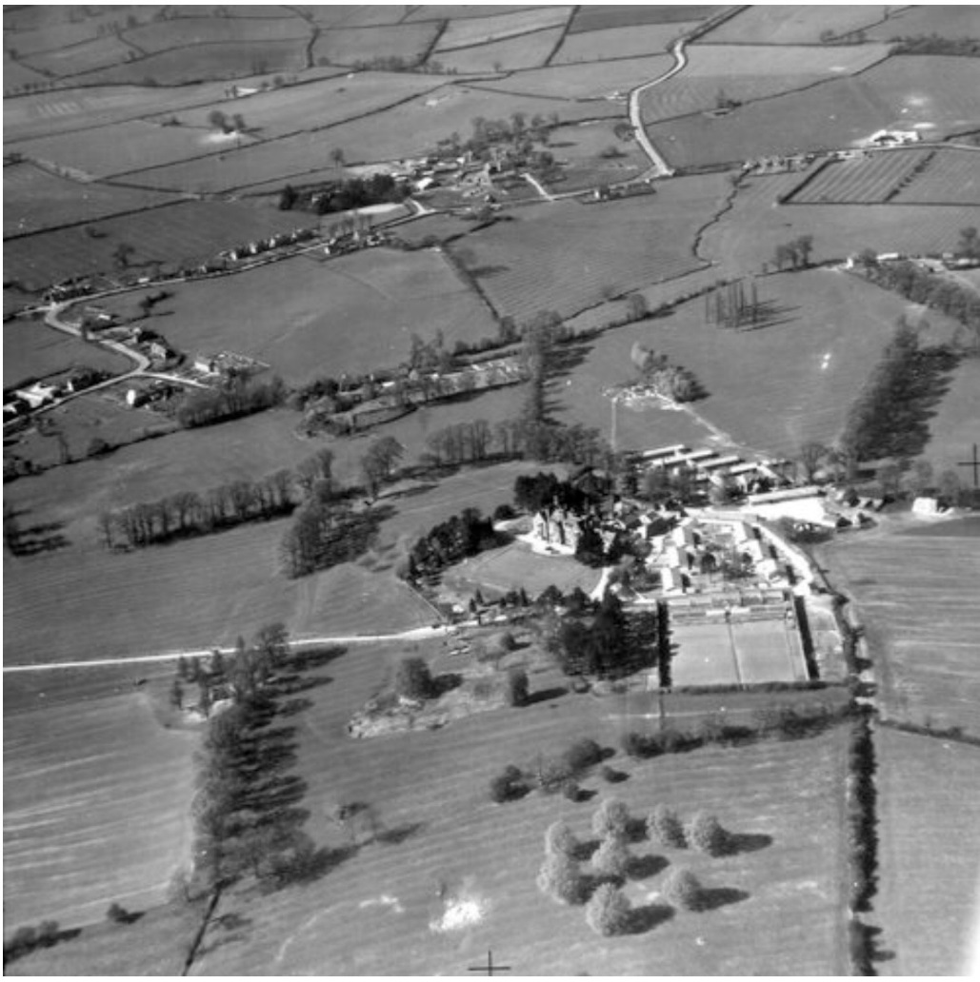
Image from c. 1950: Ridge and Furrow to the East, West and South of Grendon Hall
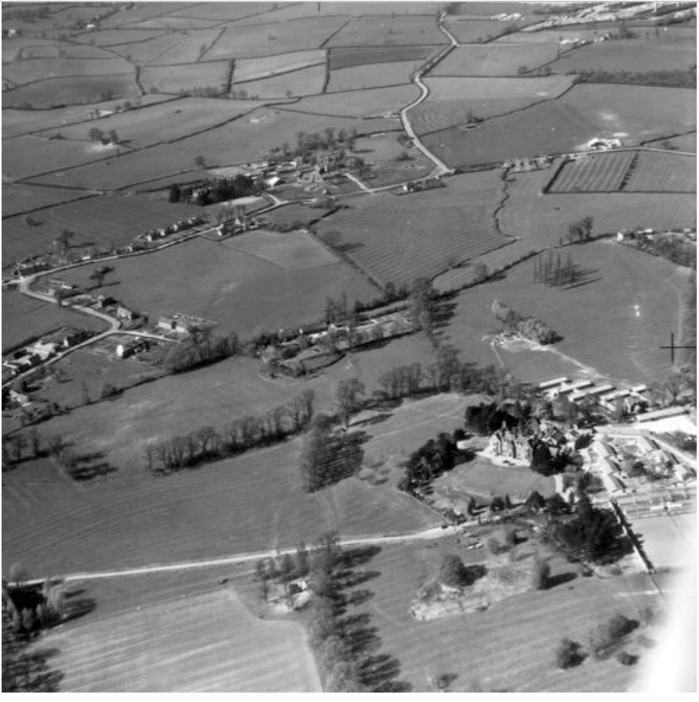
Image from c. 1950: Ridge and Furrow clearly visible on either side of the approach road to Grendon Hall

In addition to the ridge and furrow here are a few more facts about historical findings in the locality:

- Prehistoric items found in Grendon Underwood were a Neolithic stone axe-head found in the garden of a bungalow on Main Street and a Neolithic/Bronze age flint scraper found in the grounds of HMP Springhill Prison. This is unusual for this part of Buckinghamshire and it would be interesting to find any other evidence of prehistoric activity.

- Whilst there is only limited known archaeology within the site boundary, an assessment of currently available evidence for the wider areas has indicated a potential for the survival of as yet unrecorded archaeological remains within the site, comprising a moderate potential for remains relating to prehistoric activity which is likely to have been impacted by medieval farming practices. Whilst the significance of any remains is unknown, truncated prehistoric remains could be of medium significance in enhancing knowledge of activity within the area, although this significance is likely to be lower due to the loss of integrity and poor survival from extensive historical ploughing.

- There is considered to be the potential for effects upon the setting of two designated heritage assets, comprising the Grade II Grendon Hall and Lawn House. In relation to these assets, the site represents part of the wider agricultural hinterland of Grendon Underwood with ridge and furrow earthworks providing evidence for the cultivation of the landscape that dates to at least the medieval period. As such the site may be considered to make a contribution to the historical interest of the listed buildings by reflecting the previous agrarian economy and livelihood of the village in an area which borders its historic core and is visible from highways and public rights of way.

- Some medieval sites are recorded in historic documents. There is a record of 30 trees being cut for a windmill at Grendon Underwood in 1234, which is also recorded as late as 1758 but not afterwards. It was probably in the field named Mill Hill. Other medieval sites are only known from earthworks, such as the moats north-west and north of Grendon Underwood Church that may have surrounded houses. There are also earthworks of a larger medieval village east of the Grange, south of the Mission Hall and both east and west of the church. There is both a 16th century record of a fishpond belonging to Thomas Piggott and recent knowledge of a fishpond near Woodland Farm that survived until it was bulldozed around 1945. Medieval pottery and footings of a possible building were found around Manor Farm in groundworks in the 1970s. There is also a great deal of ridge-and-furrow, the preserved remains of medieval farming methods, around the parish.

- Roadworks in the early 20th century at Ham Green uncovered Roman pottery, tile and metalwork and a local archaeologist then undertook some excavation trenches. The results suggested that this was the site of a settlement in the 3rd or 4th century AD. Recent work on a pipeline nearby has uncovered a Roman building. This is not too surprising a find as the Roman road known as Akeman Street (now the A41) passes through the parish.

Table of local findings shown below from the Buckinghamshire Historical Environment Record (HER).

HER reference | Designation  Status* | Description
0569900000 | HER | SPRINGHILL PRISON GROUNDS: Neolithic or Bronze Age flint tool found by chance
MBC29141 | PLN | 17th century to late Iron Age finds recovered during a metal detecting rally
0042700000 | PLN | Field survey of medieval moat
0042500000 | SAM | Medieval moat recorded in field survey
* COA = conservation area; LB = listed building; RPG = registered historic park; SAM = scheduled monument; PLN = planning notification area (undesignated area of archaeological interest); HER = historic environment record

- Areas of ridge and furrow, like all archaeological sites, contain information relating to aspects of the past that has value for present and future generations. This information can be considered under the general headings of social including economic, historical, scientific and aesthetic information. Ridge and furrow can yield this information at scales of investigation ranging from the molecular, through to the macroscopic to entire landscapes and some of the information can only be retrieved at the appropriate scale. Our access to the cultural value of ridge and furrow is circumscribed by current methodologies, i.e. by our ability to recover this information or to preserve it in forms that will facilitate future recovery.

- Cultivated landscapes in general, and ridge and furrow in particular, contain information about the practices of tillage, e.g. the physical preparation of the soil for cultivation, manuring, crops, use for grazing and pastures, etc. These, in turn, indicate particular social and economic practices and arrangements. Within the landscape, superimposition of one set of ridges on another, whether of the same form or not, is evidence of repeated use of the landscape that may not be detectable

- Extensive, combined or juxtaposed areas of ridge and furrow give evidence of larger units of landscape organisation and chart the agricultural fortunes of villages, towns, abbeys, etc.

- The activities of many individuals and some groups fall below the awareness threshold of formal history, circumscribed as it is by written records. Ridge and furrow may represent the only record of their activities. Small areas of ridge and furrow may represent the activities of single households or indicate marginal cultivation. Ridge and furrow enriches the character of the modern landscape.

- Where a group of fragments of a once much larger continuum of ridge and furrow survive, their preservation may be considered desirable because they represent the remains of a landscape. Conversely, small isolated areas may be significant because they represent single period cultivation of marginal lands resulting from social or economic pressures.

- Any Other Points
Include any other relevant information or sources that might help in making the objection, including photos to highlight the current archaeological features of the site and surrounding area and what might be lost.
Residents to include any personal stories and or photos.

